**7 SCIENCE CHEMISTRY VOCABULARY TEST REVISION**

Name: _________________

**1. Fill in the table below.**

|  |  |
| --- | --- |
| **Word** | **Definition** |
| Solute |  |
| Solvent |  |
| Soluble |  |
| Insoluble |  |
| Concentration |  |
| Dilute |  |
| Concentrated |  |

**2. Can light pass through a solution?** ____________

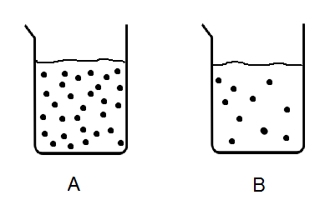**3. Which of these solutions is dilute?** _____________

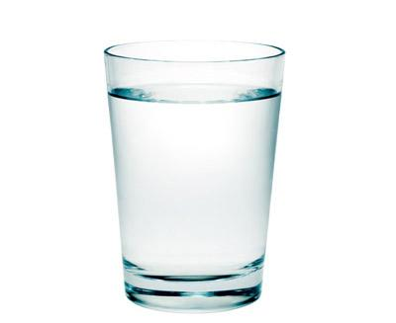**4. Here is a glass of sugar dissolved in hot water.**

a) What is the solution? ______________________________________________

b) What is the solute? _______________________

c) What is the solvent? ______________________

d) How could you make this solution saturated?

_______________________________________________________________________________________

**5. What are the three main types of mixtures?**

_______________________________________________________________________________________

**6. Suspensions**

a) In a suspension, one substance does not d___________________ in another.

b) Eventually, the substance that does not dissolve s_______________ to the bottom.

**7. Colloids**

a) Write a definition for ‘colloid’: ____________________________________________________________

_______________________________________________________________________________________

b) There are four types of colloids, list them.

_______________________________________________________________________________________

c) One type of colloid is an emulsion, write a definition for ‘emulsion’: ______________________________

_______________________________________________________________________________________

8. Fill in the table below

|  |  |  |  |
| --- | --- | --- | --- |
| **Type of mixture** | **Can a beam of**  **light pass through**  **it?** | **Does a part of the**  **mixture settle to**  **the bottom of the container?** | **Write an example of this mixture** |
| Solution |  |  |  |
| Suspension |  |  |  |
| Colloid |  |  |  |

**9. Separating insoluble substances**

**These are the ways in which insoluble substances can be separated from each other.**

Gravity separation, sieving, filtration, magnetic separation, centrifuging and electrostatic separation.

For each of the separation methods, write two dot points with the most important information about them.

**Gravity separation**

⮚

⮚

**Sieving**

⮚

⮚

**Filtration**

⮚

⮚

**Magnetic separation**

⮚

⮚

**Centrifuging**

⮚

⮚

**Electrostatic separation**

⮚

⮚

**10. Write the correct letter next to the different pictures showing separation techniques.**

Gravity separation: **A** Sieving: **B** Filtration: **C** Magnetic separation: **D**

Centrifuging:  **E** Electrostatic separation:  **F**

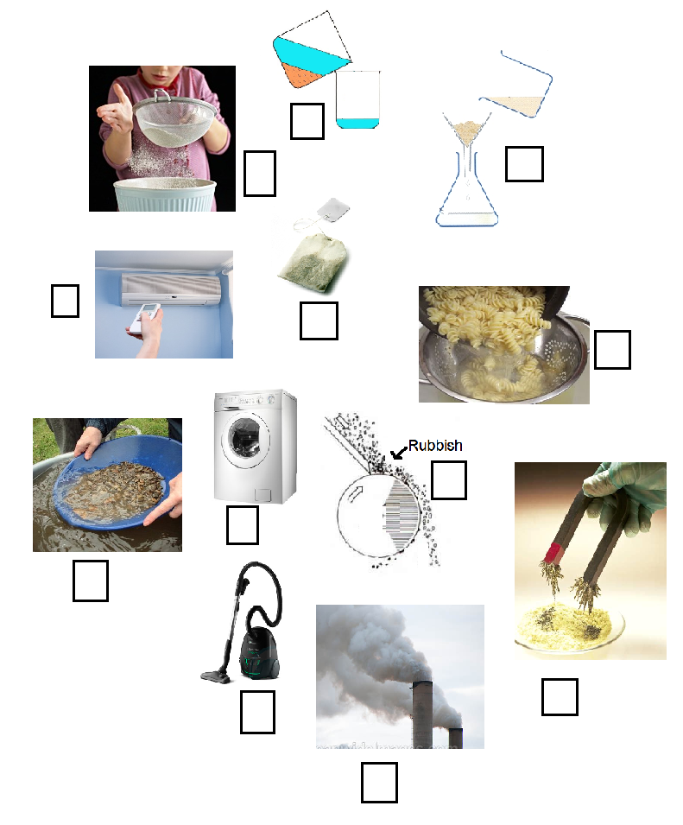

**11. Separating soluble substances from each other.**

The separating methods are chromatography, evaporation, distillation and adsorption.

For each of the separation methods, write two dot points with the most important information about them.

**Chromatography**

⮚

⮚

**Evaporation**

⮚

⮚

**Distillation**

⮚

⮚

**Adsorption**

⮚

⮚

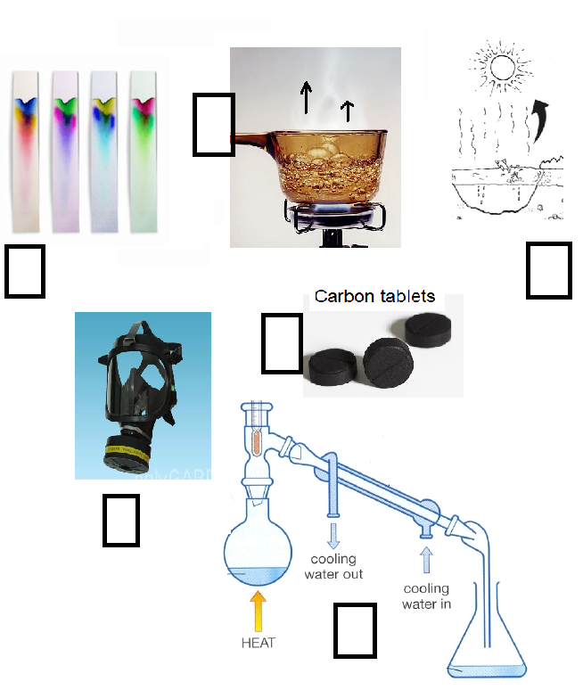

**12. Write the correct letter next to the different pictures showing separation techniques.**

Chromatography: **A**

Evaporation: **B**

Distillation: **C**

Adsorption: **D**

**13. What separation process is the equipment below used for?** ______________________________________

a) Explain why there is cold water running around the glass tube.

_______________________________________________________________________________________________

_______________________________________________________________________________________________

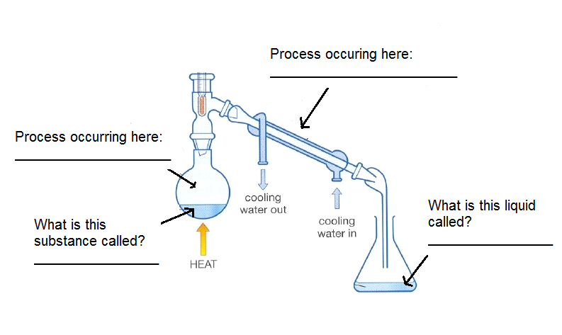

14. What separation process is the equipment below used for? _______________________________________

